1. Find a class.
To start the registration process, click “Catalog”.
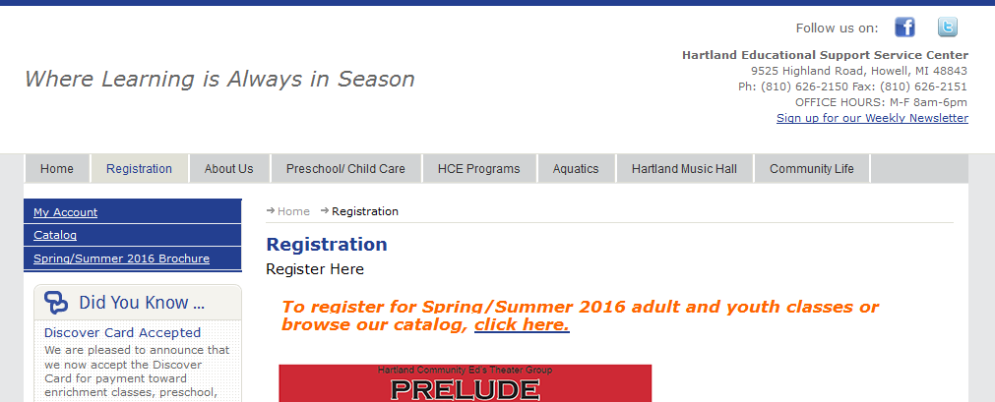

Use either the Browse or Search options to find the class you want. Once you have found a class, click the Shopping Cart icon to select the class.
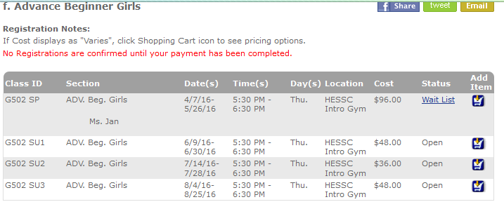
(Wait List means the class is currently full, but you can add your name to the wait list, should a space become available.)

2. Log in.
Once you select an item from the catalog, you will be asked to sign in. Logging in to any one of your family members will give you access to register all family members. If nobody has an Account Profile, you can create one. If you are unsure if you have an account, please use the “Forgot Your Password?” link, or contact our office.
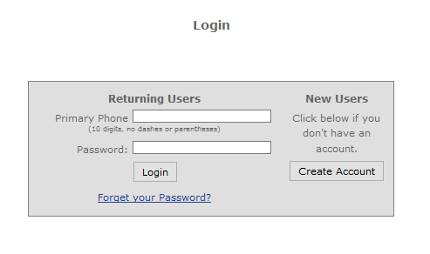
3. Complete registration forms.
Once logged in, you will be directed to the registration page for the class you had selected. Depending on the class needs, you may have additional questions to answer.
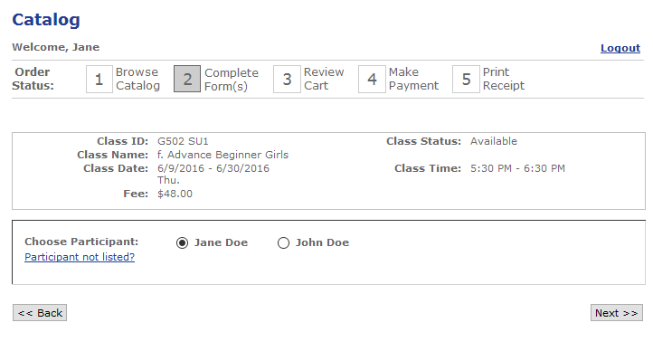
Choose the family member who will be participating in the class. If not listed, click “Participant not listed?” to create a profile for that person. If a class for a child, be sure the child is listed as the participant, not the parent.
Answer any other questions, then click “Next”

4. Review Cart.
On this page you can remove, update, or add to your cart.
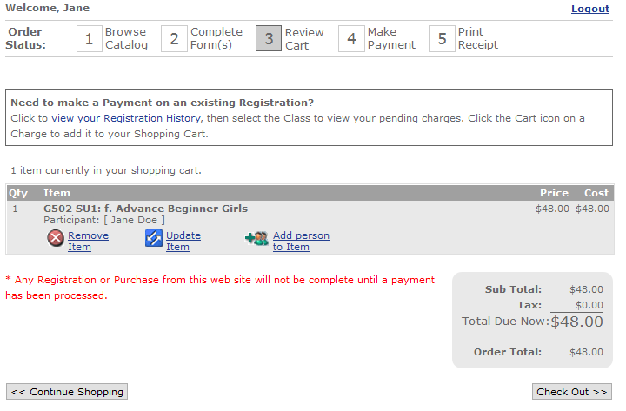
“Remove Item” if you no longer want to purchase this item.
“Update Item” to change an answer or change participant.
“Add person to Item” to register another family member for the same class.
“Continue Shopping” to go back to the catalog and find another class.
“Check Out” when you’re ready to pay.

4. Pay.
If you have registered before, you may have a payment method on file with the credit card processing bank (no credit card information is stored on Hartland’s database). If you don’t have a card on file, or want to use a different card, click “Manage Payment Methods” and follow instructions to add a credit/debit card. After selecting the card that will be used for payment, click “Next” and you will be given a receipt. A confirmation for classes will also be emailed to you.
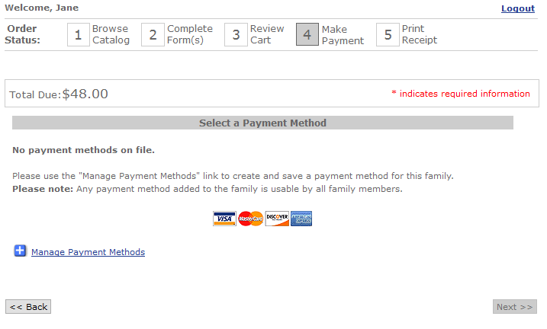

Create or update an Account Profile.
Make sure each person in your family who will be participating in classes has his/her own profile. It is important that we don’t have parents on the roster for a youth class, or otherwise have the wrong person registered.

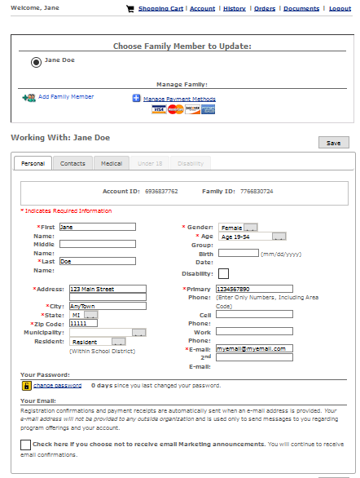
To change your password, click “Change Password”, and follow the prompts.
To edit your information, change data as needed and click “Save”
Click the “Add Family Member” to add a family member to your account.

To review classes you or a family member have already registered for:
Click “History”. Then from the dropdown, choose the family member whose registration history you wish to view. Any classes they have registered for will appear.

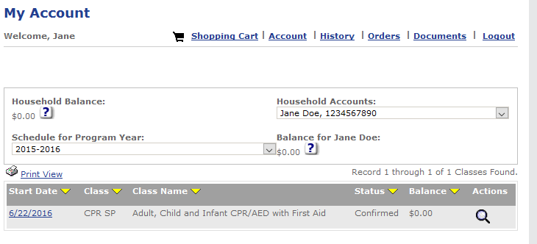
Click the magnifying glass to see more about this class. You can review class details (dates, times location, etc), print payment receipts, or make payments on unpaid charges.

